- Copyright for test papers and marking guides remains with West Australian Test Papers.
- The papers may only be reproduced within the purchasing school according to the advertised conditions of sale.
- Test papers must be withdrawn after use and stored securely in the school until Wednesday 14th October 2015.

HUMAN BIOLOGICAL

SCIENCE

STAGE 3

2015


Name: _______________________________________________________

Teacher: ___________________________________________________

TIME ALLOWED FOR THIS PAPER

Reading time before commencing work: Ten minutes
Working time for the paper: Three hours

MATERIALS REQUIRED/RECOMMENDED FOR THIS PAPER

To be provided by the supervisor:
- This Question/Answer Booklet
- Multiple Choice Answer Sheet

To be provided by the candidate:
- Standard items: Pens, pencils, eraser or correction fluid, ruler, highlighter, ruler.

- Special items: Calculators satisfying the conditions set by the Curriculum Council for this subject.

IMPORTANT NOTE TO CANDIDATES

- No other items may be taken into the examination room. It is your responsibility to ensure that you do not have any unauthorised notes or other items of a non-personal nature in the examination room. If you have any unauthorised material with you, hand it to the supervisor before reading any further.
.
Structure of this paper

Section | Number of questions available | Number of questions to be answered | Suggested working time (minutes) | Marks available | Percentage of exam
Section One: Multiple-choice | 30 | 30 | 40 | 30 | 30
Section Two:  Short answer | 8 | 8 | 90 | 100 | 50
Section Three:  Extended answer | 3 | 2 | 50 | 40 | 20
 |  |  |  | Total | 100

Instructions to candidates

- The rules for the conduct of Western Australian external examinations are detailed in the Year 12 Information Handbook 2015. Sitting this examination implies that you agree to abide by these rules.

- Answer the questions according to the following instructions.

Section One: Answer all the questions on the separate Multiple-choice Answer Sheet provided. For each question shade the box to indicate your answer. Use only a blue or black pen to shade the boxes. If you make a mistake, place a cross through that square, do not erase or use correction fluid, and shade your new answer. Marks will not be deducted for incorrect answers. No marks will be given if more than one answer is completed for any question.

Sections Two and Three: Write answers in this Question/Answer Booklet.

- You must be careful to confine your responses to the specific questions asked and to follow any instructions that are specific to a particular question.

- Spare pages are included at the end of this booklet. They can be used for planning your responses and/or as additional space if required to continue an answer.

- Planning: if you use the spare pages for planning, indicate this clearly at the top of the page.

- Continuing an answer: if you need to use the space to continue an answer, indicate in the original answer space where the answer is continued, i.e. give the page number. Fill in the number of the question(s) that you are continuing to answer at the top of the page.

Section One: Multiple-choice 30% (30 marks)

This section has 30 questions. Answer all questions on the separate Multiple-choice Answer Sheet provided. For each question, shade the box to indicate your answer. If you make a mistake, place a cross through that square, then shade your new answer. Marks will not be deducted for incorrect answers. No marks will be given if more than one answer is completed for any question.
Suggested working time: 40 minutes.

- Polymerase chain reaction (PCR) is a technique that

- allows bacterial plasmids to incorporate foreign DNA.
- uses primers to make new DNA strands.
- detects genetic abnormalities.
- requires the use of restriction enzymes to join pieces of DNA.

- An infant receiving antibodies through breast milk is an example of which form of immunity?

- active, artificial
- active, natural
- passive, artificial
- passive, natural

Question 3 refers to the diagram below, which shows three different types of neurons.
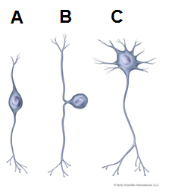
- Which of the following names structure A, B and C correctly?

 | Structure A | Structure B | Structure C
(a) | Bipolar neuron | Sensory neuron | Motor neuron
(b) | Inter-neuron | Sensory neuron | Multipolar neuron
(c) | Motor neuron | Unipolar neuron | Inter-neuron
(d) | Inter-neuron | Motor neuron | Sensory neuron
- A symptom of a person with hyperthyroidism would include

- slow heart rate.
- weight gain.
- intolerance to cold.
- increased appetite.

- Which of the following does not describe a feature of the hypothalamus?

- Produces hormones for both the anterior and posterior pituitary
- Regulates body temperature and water intake
- Uses nerve fibres to send chemicals to the posterior pituitary
- Regulates the autonomic nervous system

Questions 6 and 7 refer to the diagram of the cell membrane below.

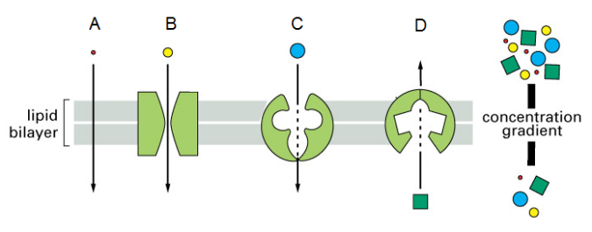

- Which letter below represents the process of active transport?

- A
- B
- C
- D

- Sodium ions moving across a cell membrane during depolarisation would best be represented by letter

- A
- B
- C
- D

Questions 8 and 9 refer to the information below.

Jamie and Quinn are enjoying some time prospecting for gold in the Outback. By the afternoon, the temperature rises to 41°C and they decide to finish their activities as they are both suffering from headaches and have run out of bottled water.

- Temperature regulation in the boys’ bodies would involve

- vasoconstriction to the arterioles of the muscle.
- reduced nerve impulses to the sweat glands.
- vasodilation of the arterioles of the skin.
- increased sympathetic impulses to the adrenal medulla to trigger the release of noradrenaline.

- The filtrate in the kidneys would

- be altered as a result of less ADH circulating in the blood.
- become more concentrated.
- increase in volume.
- have a higher proportion of water compared to the blood.

Question 10 and 11 refer to the diagram below which represents a part of protein synthesis.
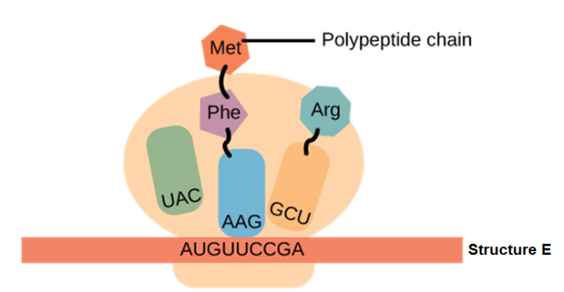

- The process shown in the diagram above is
- transcription and occurs in the nucleus
- translation and occurs in the nucleus
- transcription and occurs in the cytoplasm
- translation and occurs in the cytoplasm

- The structure labelled ‘E’

- is assembled by DNA polymerase.
- passes through the pores in the membrane to the outside of the cell.
- has information grouped into a series of three bases called a codon.
- contains the base uracil that is complementary to the DNA base thymine.

- Which of the following shows the components of the reflex arc in the correct sequence?

- Stimulus, receptor, sensory neuron, inter-neuron, motor neuron, effector
- Stimulus, effector, motor neuron, inter-neuron, sensory neuron, receptor
- Stimulus, receptor, motor neuron, inter-neuron, sensory neuron, effector
- Stimulus, effector, sensory neuron, inter-neuron, sensory neuron, receptor

Question 13 refers to the diagram below, which shows the rock strata from four different locations.

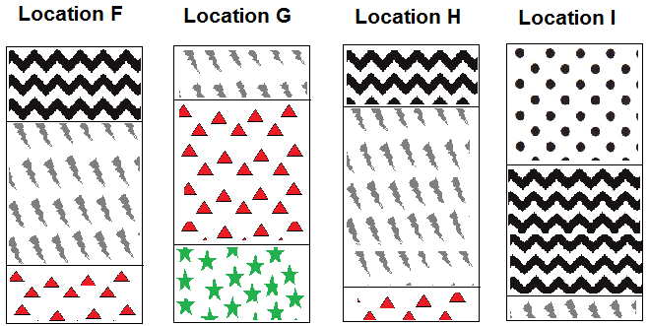

- The youngest stratum is found in Location

- F
- G
- H
- I

- Which one of the following statements regarding control of gene expression is correct?

- Regulator genes allow DNA polymerase to bind to a structural gene.
- RNA polymerase binds to the promoter gene.
- Promoter genes contain information to make repressor proteins.
- If a regulator gene is actively producing a repressor protein then the associated structural gene will be switched on.

- Below is a list of factors that may affect the evolution of gene pools.

- Mutation
- Natural selection
- Random genetic drift
- Migration
- Barriers to gene flow
Which of the following are most likely to introduce new alleles into a gene pool?

- (i), (ii), (iii) and (v)
- (i) and (iv)
- (i) alone
- (i), (iii) and (iv)

- Homo heidelbergensis is thought to have been then ancestor of Homo neanderthalensis and Homo sapiens.

Which sequence of events would lead to the rise of two distinct species?

- Natural selection, variation, speciation, isolation
- Variation, isolation, speciation, natural selection
- Isolation, variation, natural selection, speciation
- Varation, isolation, natural selection, speciation

- Which of the following correctly matches the hominin to the associated lifestyle change?

- Homo habilis – food sharing, Homo neanderthalensis – cave murals
- Homo erectus – use of fire, Homo sapiens – first to perform ritualised burials
- Homo neanderthalensis – development of agriculture, Australopithecines – home bases
- Homo habilis – food sharing, Homo erectus – cooperative hunting

- Bipedalism first became an advantage when environmental change resulted in

- an increase in open grassland relative to forests.
- an increase in height of food supply found on trees.
- an increase in global temperatures.
- a decrease in the amount of high energy foods like meat.

- A microscopic view of cartilage would show

- osteocytes trapped in matrix of chondrin.
- Haversian systems arranged in concentric rings.
- collagen fibres arranged in a matrix around chondrocytes.
- lacunae containing trapped osteocytes.
- Which of the following represents a joint that can only perform flexion or extension?

- ball and socket
- hinge joint
- pivot
- gliding

- An individual suffering from excessive levels of calcium circulating in the blood would most likely have a dysfunctional

- thyroid.
- pancreas.
- parathyroid.
- adrenal gland.

- The autonomic and somatic divisions of the nervous system are both responsible for motor pathways but they are structured very differently.

Which of the following is correct?

- Autonomic affects skeletal muscles, somatic affects involuntary muscle.
- Autonomic has one type of neurotransmitter released at the effector while somatic has two possible types of neurotransmitter released at the effector.
- Autonomic has two sets of nerves to the target organ while somatic only has one set of nerves to the target organ.
- Autonomic has no synapse or ganglion outside the CNS, whereas somatic does have a synapse and a ganglion outside the CNS.

- During cycling practice, Evan notices his breathing rate dramatically increases.

The reason for this response is

- the pH level of his blood has increased, triggering his chemoreceptors.
- the number of hydrogen ions in his blood has decreased causing a response coordinated by the medulla oblongata
- chemoreceptors in the hypothalamus detected elevated levels of carbon dioxide.
- the medulla oblongata sends increased impulses to the diaphragm and intercostal muscles.

- Homologous organs are used as evidence for evolution because

- their similar functions suggest a common ancestor.
- their lack of similarities suggests that natural selection has occurred.
- it shows their common ancestor was able to survive in many different environments.
- their similar design suggests divergence from a common ancestor, with modifications to suit different environments.
- Which of the following is not a description of spinal reflexes?

- acquired
- stereotyped
- rapid
- protective

- Infants take a long time to learn how to walk. Their brain requires feedback about the movements from all of the structures below except the

- saccule and utricle of the inner ear.
- photoreceptors of the eye.
- stretch receptors in the muscles and joints.
- chemoreceptors in blood vessels in the muscles.

- Euthanasia is currently illegal in Australia but an argument being held to support its introduction is sufferers

- are incapable of making rational decisions.
- are shown more respect if they can choose when to end their life.
- should have faith that their condition will become curable in the future.
- are more of a burden on the health system if they are allowed to end their life through choice.

- Which of the following is a correct comparison of B and T lymphocytes?

 | B lymphocyte | T lymphoctye
(a) | Destroys antigen | Matures in the bone marrow
(b) | Can become a helper cell | Causes agglutination
(c) | Involved in antibody production | Can become memory cells
(d) | Responds to cells infected with viruses | Matures in the thymus

- Alzheimer’s disease is characterised by

- damage to the cerebral cortex resulting in impaired memory and thought processes.
- the large number of medications available for treatment.
- reduced levels of dopamine.
- the build up of plaques and tangles in the spinal cord.

Question 30 refers to the diagram below, which illustrates research being conducted into a potential treatment for Alzheimer’s disease.

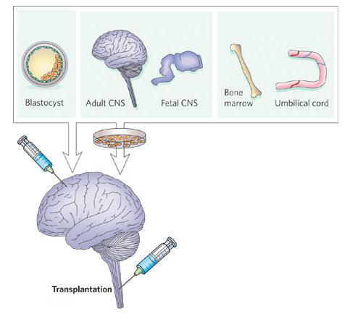

- This type of biotechnology would be best described as

- tissue engineering
- stem cell therapy
- artificial replacements
- gene therapy

Section Two: Short Answer 50% (100 marks)

This section has eight (8) questions. Answer all questions. Write your answers in the spaces provided.

Suggested working time: 90 minutes.

Question 31 (12 marks)

Part (a) of the question refers to the diagram of a joint below.

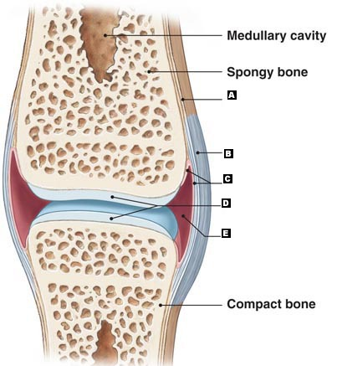

- Identify structures C, D and E indicated by labels on the diagram. (3 marks)

C ________________________________________________________________________

D ________________________________________________________________________

E ________________________________________________________________________

- In the table below, summarise the features of two other types of joints (4 marks)

Type of Joint | Description | Example
Immoveable
Cartilaginous

- Osteoarthritis is a disease usually associated with ageing that affects the skeletal system.

- State the part of the joint that, when damaged, leads to osteoarthritis. (1 mark)

____________________________________________________________________

- Name two other symptoms that a person would have if the area in part (b)(i) was damaged. (2 marks)

________________________________________________________________________________________________________________________________________________________________________________________________________________________________________________________________________________

- State two medical technologies currently available for the treatment of this disease. (2 marks)
________________________________________________________________________________________________________________________________________________________________________________________________________________________________________________________________________________

Question 32 (13 marks)

Part (a) of the question refers to the tool diagrams A, B, C and D shown below.

A B C D
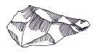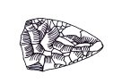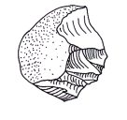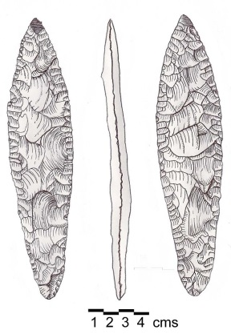

- Complete the table below by placing the tools A, B, C and D in the correct evolutionary sequence, from oldest to most recent. Include the hominin species it is associated with.
(4 marks)

Letter –  A, B, C or D | Name of Tool Culture | Used by
 | Oldest
 | Youngest

- Hominin tool culture has distinctly changed over time.

List one trend relating to (2 marks)

- manufacture – ________________________________________________________ ________________________________________________________________________________________________________________________________________
- use – _______________________________________________________________ ________________________________________________________________________________________________________________________________________
- It is believed that tool use became possible with the transition to bipedalism.

Explain an adaptation for each biological structure that could have led to the evolution of bipedalism. (4 marks)

Structure | Adaptation | How this assists bipedal movement
Foot
Hip Joint

- Hominin skulls exhibit many changes though time.

State three evolutionary trends evident in hominin skulls. (3 marks)

____________________________________________________________________________________________________________________________________________________________________________________________________________________________________________________________________________________________________________________________________________________________________________________________________________________________________________________________

Question 33 (13 marks)

Amelia is lying on the couch watching TV when she smells her toast burning. She quickly jumps up but then suddenly feels light-headed and dizzy. Her friend, Jonah, explains to her that she feels this way because her blood pressure has dropped and it will be short-lived due to a stimulus-response feedback loop.

- List the components of a stimulus-response feedback loop in the correct sequence. (1 mark)
______________________________________________________________________________________________________________________________________

- Describe three responses by Amelia’s body that prevent her blood pressure from remaining low. (3 marks)

____________________________________________________________________________________________________________________________________________________________________________________________________________________________________________________________________________________________________________________________________________________________________________________________________________________________________________________________

- Which part of the brain is responsible for coordinating the responses in part (b)? (1 mark)

__________________________________________________________________________

- Provide two other diseases or environmental circumstances that could lead to hypotension (low blood pressure). (2 marks)

________________________________________________________________________________________________________________________________________________________________________________________________________________________________________________________________________________________________________

- Control of blood pressure relies on both the nervous and endocrine systems.

Complete the table below, outlining the ways that these coordinating systems differ.
(6 marks)

 | Endocrine | Nervous
Time for reaction to occur
Duration
Specificity

Question 34 (15 marks)

Duchenne muscular dystrophy is a genetic disease that progressively weakens the muscles of an affected individual. There is no cure for the disease but medication and physical therapy can help alleviate symptoms.

A new drug called Petrilnez is being trialled with hopes of slowing the progression of the disease by increasing the strength of their muscles.

A clinical trial was carried out with 16 patients suffering from Duchenne muscular dystrophy. Every week, eight subjects were injected with 30mg/kg of the new drug while the other eight were injected with 30mg/kg of a placebo. Every ten weeks they were required to walk for a total of 5 minutes and the distance each subject travelled was recorded. This was carried out over a period of fifty weeks.

The table below shows the average results for both trial groups over the fifty weeks.

 | Distance Travelled (metres)
Time (weeks) | Subjects using Petrilnez | Subjects using placebo
0 | 80 | 81
10 | 72 | 73
20 | 76 | 52
30 | 74 | 18
40 | 69 | 3
50 | 96 | 12

- Propose a hypothesis for this investigation. (1 mark)

____________________________________________________________________________________________________________________________________________________

- State two variables that were controlled in the experiment. (2 marks)

________________________________________________________________________________________________________________________________________________________________________________________________________________________________________________________________________________________________________

- Graph the results on the grid provided below. (5 marks)



- In 1986, researchers identified a gene that, when mutated, caused Duchenne muscular dystrophy. Couples with a family history of this disease may wish to undergo DNA profiling to determine their risks of conceiving a child with this disease.

- Explain how the process of electrophoresis is able to create a DNA profile for this couple. (4 marks)

____________________________________________________________________________________________________________________________________________________________________________________________________________________________________________________________________________________________________________________________________________________________________________________________________________________________________________________________________________________________________________________________________________________________________________________________________________________________________

- Once a DNA profile is created, the DNA is denatured and exposed to a genetic probe. Explain what a genetic probe is and how it is used to identify whether the couple carry the mutation for Duchenne muscular dystrophy. (3 marks)

________________________________________________________________________________________________________________________________________________________________________________________________________________________________________________________________________________________________________________________________________________________________________________________________________________________

Question 35 (12 marks)

Part (a) of the question refers to the diagram of a primate cladogram below.

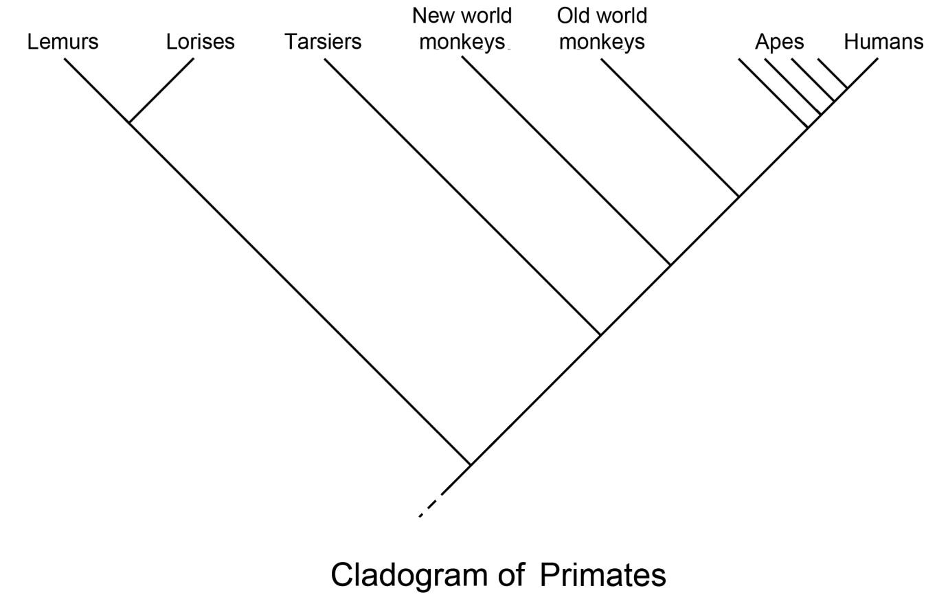

- According to the cladogram, which group of primates was the first to diverge in evolutionary time? (1 mark)

__________________________________________________________________________

- Complete the table below, describing three Primate evolutionary trends. (3 marks)

Trend | Significance
Relative size of the cerebral cortex
Olfactory / optical shift
Parental care

- Scientists trying to establish the evolutionary relationship between primates decided to complete a comparative study using nuclear DNA.

- Describe how this would be conducted. (2 marks)

________________________________________________________________________________________________________________________________________________________________________________________________________________________________________________________________________________

- Explain how it could show evolutionary relationships between primates. (1 mark)

______________________________________________________________ ______________________________________________________________ ______________________________________________________________

- Palaeontologists are yet to find a common ancestor for chimpanzees and humans in the fossil record. It is thought to have lived between 5 and 7 million years ago.

- Suggest three reasons why such a fossil has been hard to find. (3 marks)

____________________________________________________________________________________________________________________________________________________________________________________________________________________________________________________________________________________________________________________________________________________

- A scientist who is completing excavations in Eastern Africa unearths a fossil he believes is the ‘missing link’ between chimpanzees and humans. If this is true, explain why C-14 dating would be of little use in this scenario. (2 marks)

____________________________________________________________________________________________________________________________________________________________________________________________________________

Question 36 (12 marks)
Parts (a) and (b) refer to the diagram below that represents the microscopic structure of human muscle.

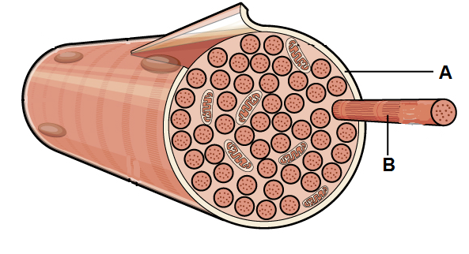

- Identify the structures labelled A and B. (2 marks)

A __________________________________________________________________
B __________________________________________________________________

- Units along structure A are called sarcomeres. Draw a labelled uncontracted sarcomere and its associated components in the box below. (4 marks)

- The nervous system controls the contraction of skeletal muscle. Explain the role of the brain in achieving this. (2 marks)

________________________________________________________________________________________________________________________________________________________________________________________________________________________________________________________________________________________________________

- Describe the effect that nervous stimulation has on the structure illustrated in part (b).
(4 marks)
________________________________________________________________________________________________________________________________________________________________________________________________________________________________________________________________________________________________________________________________________________________________________________________________________________________________________________________________________________________________________________________________________________________________________________________________________________

Question 37 (12 marks)

An investigation was carried out on 40 pairs of identical twins to determine the effect of epigenetics. Researchers noted that twins that were infants had indistinguishable epigenomes, while those who were elderly had quite different epigenomes.

- State what epigenetics refers to. (1 mark)

____________________________________________________________________________________________________________________________________________________

- Explain how the epigenome can be changed by

- Histone modification (2 marks)

________________________________________________________________________________________________________________________________________________________________________________________________________________________________________________________________________________

- DNA methylation (2 marks)

________________________________________________________________________________________________________________________________________________________________________________________________________________________________________________________________________________

- Propose a reason for the different observations collected from the young and elderly sets of twins. (1 mark)

____________________________________________________________________________________________________________________________________________________

There are times when the environment alters gene expression producing a result that is relatively short-lived and not heritable. Skin pigmentation is one such example.

- Explain how the environment plays a role in altering skin pigmentation. (3 marks)

____________________________________________________________________________________________________________________________________________________________________________________________________________________________________________________________________________________________________________________________________________________________________________________________________________________________________________________________

- Skin colour is primarily controlled by polygenes. Explain how this mode of inheritance is responsible for the range of skin colour phenotypes that can be observed. (3 marks)

____________________________________________________________________________________________________________________________________________________________________________________________________________________________________________________________________________________________________________________________________________________________________________________________________________________________________________________________

Question 38 (11 marks)

Kirsten is highly allergic to peanuts and if she accidentally consumes them she has a severe allergic reaction called anaphylaxis. Symptoms of anaphylaxis include difficulty breathing and possibly death. To prevent this Kirsten needs an injection of adrenaline from an EpiPen.

- Describe how the adrenaline would act on her body to relieve breathing difficulties. (1 mark)

__________________________________________________________________________

- Identify a situation in which the body would naturally release its own supply of adrenaline and state which endocrine gland it would be released from. (2 marks)

____________________________________________________________________________________________________________________________________________________

- Adrenaline is released as a result of stimulation by the sympathetic division of the nervous system.
In the table below, describe the effects the sympathetic division has on other body structures. (3 marks)

Structure | Effect
Heart
Blood vessels of skeletal muscle
Intestines

- Adrenaline is classified as an amine hormone. Contrast the action of amine hormones with steroid hormones. (2 marks)

________________________________________________________________________________________________________________________________________________________________________________________________________________________________________________________________________________________________________

- Explain how receptor proteins interact with hormones. (3 marks)

____________________________________________________________________________________________________________________________________________________________________________________________________________________________________________________________________________________________________________________________________________________________________________________________________________________________________________________________

Section Three: Extended Answer 20% (40 marks)
This section has three (3) questions. You must answer two (2) questions. Write your answers in the lined pages provided.
Responses may include clearly labelled diagrams with explanatory notes; lists of points with linking sentences; clearly labelled tables and graphs; and annotated flow diagrams with introductory notes.
Suggested working time: 50 minutes.

Question 39

Tim was bushwalking with his friends when he was bitten on the leg by a tiger snake. On the way to the hospital, he began to feel numb and had difficulty breathing. After receiving medical care Tim was told that he was fortunate to have arrived before paralysis of his muscles set in.

- Neurotoxins are chemicals contained in the snake’s venom that mimic the shape of the acetylcholine molecule. Describe how nerve impulses are usually propagated at the synapse and explain how the neurotoxin interfered with this process in Tim’s situation.
(11 marks)

- At the hospital Tim was given an injection of anti-venom that contained tiger snake venom antibodies.

Explain how antibodies are produced in the body and describe their role in providing a defence.
(9 marks)

Question 40

- Regulation of blood glucose is important to ensure cells are able to access a ready supply of energy when required.

Describe the homeostatic mechanism that maintains blood sugar at an optimal level when a period of fasting has occurred.
(8 marks)

- It is estimated that over 1 million Australians suffer from diabetes. About 120,000 people are diagnosed with type 1 diabetes and 956,000 with type 2.

Compare and contrast the two types of diabetes individuals may suffer from and explain the management options available for each group.
(12 marks)

Question 41

The HEXA gene codes for an enzyme that breaks down lipids found within cells, mostly in the central nervous system. If both alleles for this gene are mutated, the individual will suffer from a fatal disease called Tay-Sachs.

- In Australia, the frequency of the mutated allele is very low, about 1 in 300. In the Ashkenazi Jewish population, however, the frequency is about 1 in 26.

Explain two evolutionary mechanisms that scientists reason could be the cause for such different gene pools.
(7 marks)

- Researchers are hoping to start human clinical trials for Tay-Sachs disease using gene therapy. They hope to achieve this by using modified viruses that are infused into cerebrospinal fluid.

Describe the process of how the viruses would be genetically engineered and then how it could lead to a treatment for Tay-Sachs.
(13 marks)

Question number: __________________

________________________________________________________________________________
________________________________________________________________________________________________________________________________________________________________
________________________________________________________________________________________________________________________________________________________________
________________________________________________________________________________________________________________________________________________________________
________________________________________________________________________________________________________________________________________________________________
________________________________________________________________________________________________________________________________________________________________
________________________________________________________________________________________________________________________________________________________________
________________________________________________________________________________________________________________________________________________________________
________________________________________________________________________________________________________________________________________________________________
________________________________________________________________________________________________________________________________________________________________
________________________________________________________________________________________________________________________________________________________________
________________________________________________________________________________________________________________________________________________________________
________________________________________________________________________________________________________________________________________________________________
________________________________________________________________________________________________________________________________________________________________
________________________________________________________________________________________________________________________________________________________________
________________________________________________________________________________________________________________________________________________________________
________________________________________________________________________________
________________________________________________________________________________
Question number: __________________

________________________________________________________________________________
________________________________________________________________________________________________________________________________________________________________
________________________________________________________________________________________________________________________________________________________________
________________________________________________________________________________________________________________________________________________________________
________________________________________________________________________________________________________________________________________________________________
________________________________________________________________________________________________________________________________________________________________
________________________________________________________________________________________________________________________________________________________________
________________________________________________________________________________________________________________________________________________________________
________________________________________________________________________________________________________________________________________________________________
________________________________________________________________________________________________________________________________________________________________
________________________________________________________________________________________________________________________________________________________________
________________________________________________________________________________________________________________________________________________________________
________________________________________________________________________________________________________________________________________________________________
________________________________________________________________________________________________________________________________________________________________
________________________________________________________________________________________________________________________________________________________________
________________________________________________________________________________________________________________________________________________________________
________________________________________________________________________________
________________________________________________________________________________
Question number: __________________

________________________________________________________________________________
________________________________________________________________________________________________________________________________________________________________
________________________________________________________________________________________________________________________________________________________________
________________________________________________________________________________________________________________________________________________________________
________________________________________________________________________________________________________________________________________________________________
________________________________________________________________________________________________________________________________________________________________
________________________________________________________________________________________________________________________________________________________________
________________________________________________________________________________________________________________________________________________________________
________________________________________________________________________________________________________________________________________________________________
________________________________________________________________________________________________________________________________________________________________
________________________________________________________________________________________________________________________________________________________________
________________________________________________________________________________________________________________________________________________________________
________________________________________________________________________________________________________________________________________________________________
________________________________________________________________________________________________________________________________________________________________
________________________________________________________________________________________________________________________________________________________________
________________________________________________________________________________________________________________________________________________________________
________________________________________________________________________________
________________________________________________________________________________
Question number: __________________

________________________________________________________________________________
________________________________________________________________________________________________________________________________________________________________
________________________________________________________________________________________________________________________________________________________________
________________________________________________________________________________________________________________________________________________________________
________________________________________________________________________________________________________________________________________________________________
________________________________________________________________________________________________________________________________________________________________
________________________________________________________________________________________________________________________________________________________________
________________________________________________________________________________________________________________________________________________________________
________________________________________________________________________________________________________________________________________________________________
________________________________________________________________________________________________________________________________________________________________
________________________________________________________________________________________________________________________________________________________________
________________________________________________________________________________________________________________________________________________________________
________________________________________________________________________________________________________________________________________________________________
________________________________________________________________________________________________________________________________________________________________
________________________________________________________________________________________________________________________________________________________________
________________________________________________________________________________________________________________________________________________________________
________________________________________________________________________________
________________________________________________________________________________
Question number: __________________

________________________________________________________________________________
________________________________________________________________________________________________________________________________________________________________
________________________________________________________________________________________________________________________________________________________________
________________________________________________________________________________________________________________________________________________________________
________________________________________________________________________________________________________________________________________________________________
________________________________________________________________________________________________________________________________________________________________
________________________________________________________________________________________________________________________________________________________________
________________________________________________________________________________________________________________________________________________________________
________________________________________________________________________________________________________________________________________________________________
________________________________________________________________________________________________________________________________________________________________
________________________________________________________________________________________________________________________________________________________________
________________________________________________________________________________________________________________________________________________________________
________________________________________________________________________________________________________________________________________________________________
________________________________________________________________________________________________________________________________________________________________
________________________________________________________________________________________________________________________________________________________________
________________________________________________________________________________________________________________________________________________________________
________________________________________________________________________________
________________________________________________________________________________
Question number: __________________

________________________________________________________________________________
________________________________________________________________________________________________________________________________________________________________
________________________________________________________________________________________________________________________________________________________________
________________________________________________________________________________________________________________________________________________________________
________________________________________________________________________________________________________________________________________________________________
________________________________________________________________________________________________________________________________________________________________
________________________________________________________________________________________________________________________________________________________________
________________________________________________________________________________________________________________________________________________________________
________________________________________________________________________________________________________________________________________________________________
________________________________________________________________________________________________________________________________________________________________
________________________________________________________________________________________________________________________________________________________________
________________________________________________________________________________________________________________________________________________________________
________________________________________________________________________________________________________________________________________________________________
________________________________________________________________________________________________________________________________________________________________
________________________________________________________________________________________________________________________________________________________________
________________________________________________________________________________________________________________________________________________________________
________________________________________________________________________________
________________________________________________________________________________
Question number: __________________

________________________________________________________________________________
________________________________________________________________________________________________________________________________________________________________
________________________________________________________________________________________________________________________________________________________________
________________________________________________________________________________________________________________________________________________________________
________________________________________________________________________________________________________________________________________________________________
________________________________________________________________________________________________________________________________________________________________
________________________________________________________________________________________________________________________________________________________________
________________________________________________________________________________________________________________________________________________________________
________________________________________________________________________________________________________________________________________________________________
________________________________________________________________________________________________________________________________________________________________
________________________________________________________________________________________________________________________________________________________________
________________________________________________________________________________________________________________________________________________________________
________________________________________________________________________________________________________________________________________________________________
________________________________________________________________________________________________________________________________________________________________
________________________________________________________________________________________________________________________________________________________________
________________________________________________________________________________________________________________________________________________________________
________________________________________________________________________________
________________________________________________________________________________
Question number: __________________

________________________________________________________________________________
________________________________________________________________________________________________________________________________________________________________
________________________________________________________________________________________________________________________________________________________________
________________________________________________________________________________________________________________________________________________________________
________________________________________________________________________________________________________________________________________________________________
________________________________________________________________________________________________________________________________________________________________
________________________________________________________________________________________________________________________________________________________________
________________________________________________________________________________________________________________________________________________________________
________________________________________________________________________________________________________________________________________________________________
________________________________________________________________________________________________________________________________________________________________
________________________________________________________________________________________________________________________________________________________________
________________________________________________________________________________________________________________________________________________________________
________________________________________________________________________________________________________________________________________________________________
________________________________________________________________________________________________________________________________________________________________
________________________________________________________________________________________________________________________________________________________________
________________________________________________________________________________________________________________________________________________________________
________________________________________________________________________________
________________________________________________________________________________
Question number: __________________

________________________________________________________________________________
________________________________________________________________________________________________________________________________________________________________
________________________________________________________________________________________________________________________________________________________________
________________________________________________________________________________________________________________________________________________________________
________________________________________________________________________________________________________________________________________________________________
________________________________________________________________________________________________________________________________________________________________
________________________________________________________________________________________________________________________________________________________________
________________________________________________________________________________________________________________________________________________________________
________________________________________________________________________________________________________________________________________________________________
________________________________________________________________________________________________________________________________________________________________
________________________________________________________________________________________________________________________________________________________________
________________________________________________________________________________________________________________________________________________________________
________________________________________________________________________________________________________________________________________________________________
________________________________________________________________________________________________________________________________________________________________
________________________________________________________________________________________________________________________________________________________________
________________________________________________________________________________________________________________________________________________________________
________________________________________________________________________________
________________________________________________________________________________
Question number: __________________

________________________________________________________________________________
________________________________________________________________________________________________________________________________________________________________
________________________________________________________________________________________________________________________________________________________________
________________________________________________________________________________________________________________________________________________________________
________________________________________________________________________________________________________________________________________________________________
________________________________________________________________________________________________________________________________________________________________
________________________________________________________________________________________________________________________________________________________________
________________________________________________________________________________________________________________________________________________________________
________________________________________________________________________________________________________________________________________________________________
________________________________________________________________________________________________________________________________________________________________
________________________________________________________________________________________________________________________________________________________________
________________________________________________________________________________________________________________________________________________________________
________________________________________________________________________________________________________________________________________________________________
________________________________________________________________________________________________________________________________________________________________
________________________________________________________________________________________________________________________________________________________________
________________________________________________________________________________________________________________________________________________________________
________________________________________________________________________________
________________________________________________________________________________
Question number: __________________

________________________________________________________________________________
________________________________________________________________________________________________________________________________________________________________
________________________________________________________________________________________________________________________________________________________________
________________________________________________________________________________________________________________________________________________________________
________________________________________________________________________________________________________________________________________________________________
________________________________________________________________________________________________________________________________________________________________
________________________________________________________________________________________________________________________________________________________________
________________________________________________________________________________________________________________________________________________________________
________________________________________________________________________________________________________________________________________________________________
________________________________________________________________________________________________________________________________________________________________
________________________________________________________________________________________________________________________________________________________________
________________________________________________________________________________________________________________________________________________________________
________________________________________________________________________________________________________________________________________________________________
________________________________________________________________________________________________________________________________________________________________
________________________________________________________________________________________________________________________________________________________________
________________________________________________________________________________________________________________________________________________________________
________________________________________________________________________________
________________________________________________________________________________
Additional working space
Question number: ________________
________________________________________________________________________________
________________________________________________________________________________________________________________________________________________________________
________________________________________________________________________________________________________________________________________________________________
________________________________________________________________________________________________________________________________________________________________
________________________________________________________________________________________________________________________________________________________________
________________________________________________________________________________________________________________________________________________________________
________________________________________________________________________________________________________________________________________________________________
________________________________________________________________________________________________________________________________________________________________
________________________________________________________________________________________________________________________________________________________________
________________________________________________________________________________________________________________________________________________________________
________________________________________________________________________________________________________________________________________________________________
________________________________________________________________________________________________________________________________________________________________
________________________________________________________________________________________________________________________________________________________________
________________________________________________________________________________________________________________________________________________________________
________________________________________________________________________________________________________________________________________________________________
________________________________________________________________________________________________________________________________________________________________
________________________________________________________________________________
Additional working space
Question number: ________________
________________________________________________________________________________
________________________________________________________________________________________________________________________________________________________________
________________________________________________________________________________________________________________________________________________________________
________________________________________________________________________________________________________________________________________________________________
________________________________________________________________________________________________________________________________________________________________
________________________________________________________________________________________________________________________________________________________________
________________________________________________________________________________________________________________________________________________________________
________________________________________________________________________________________________________________________________________________________________
________________________________________________________________________________________________________________________________________________________________
________________________________________________________________________________________________________________________________________________________________
________________________________________________________________________________________________________________________________________________________________
________________________________________________________________________________________________________________________________________________________________
________________________________________________________________________________________________________________________________________________________________
________________________________________________________________________________________________________________________________________________________________
________________________________________________________________________________________________________________________________________________________________
________________________________________________________________________________________________________________________________________________________________
________________________________________________________________________________

Acknowledgements

Question 3: Illustration of neurons from http://www.semayjohnston.com/

Questions 6 & 7: Essential Cell Biology (Second Edition), Bruce Alberts, Dennis Bray, Alexander Johnson, Julian Lewis, Martin Raff, Keith Roberts and Peter Walter (Garland Publishing 2004)

Questions 10 & 11: Section on Translation, Elongation and Termination (Figure 1) from
http://philschatz.com/biology-book/contents/m44529.html

Question 30:
https://neurowiki2012.wikispaces.com/Stem+cell+therapies+in+Alzheimer%27s+Disease

Question 31: Illustration of a representative simple synovial joint (sagittal section) from
http://wps.aw.com/bc_martini_eap_5/108/27708/7093460.cw/

Question 32: three diagrams from http://australianmuseum.net.au/hominin-tools and
http://en.wikipedia.org/wiki/Beirut#mediaviewer/File:Canaanean_Blade.jpg

Question 35: http://upload.wikimedia.org/wikipedia/commons/a/a2/Primate_cladogram.jpg

Question 36: http://commons.wikimedia.org/wiki/File:1022_Muscle_Fibers_%28small%29.jpg

